**CSA1445-CRYPTOGRAPHY AND NETWORK SECURITY FOR CYBER SECURITY**

NAME: MURALI KRISHNAN S

REG NO: 192321093

**PROGRAM 1**

**Develop a lexical Analyzer to identify identifiers, constants, operators using C program.**

**Aim**:  
To identify and print the arithmetic operators +, -, *, and / from a given input string.

**Code:**

#include <stdio.h>

int main() {

char ch;

printf("Enter a string of arithmetic expressions: ");

while ((ch = getchar()) != '\n') {

if (ch == '+' || ch == '-' || ch == '*' || ch == '/') {

printf("Operator: %c\n", ch);

}

}

return 0;

}

**Output:**

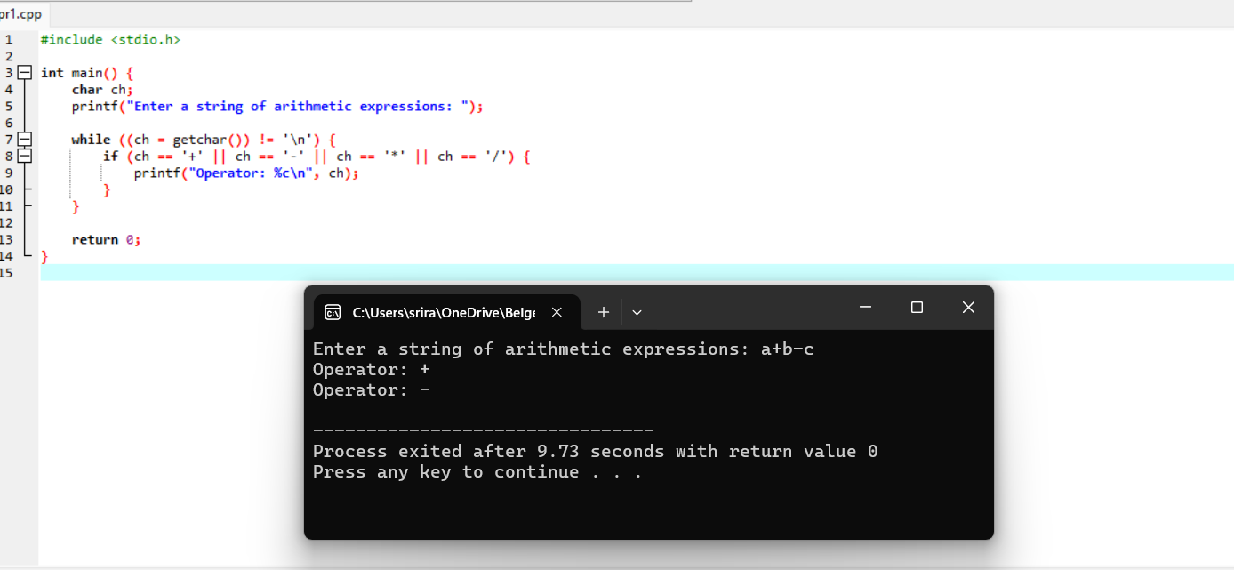

**PROGRAM 2**

Develop A Lexical Analyzer To Identify Whether A Given Line Is A Comment Or Not Using C

Aim:

To ignore spaces, tabs, newlines, and comments (// for single-line comments and /* */ for multi-line comments) while processing the input.

Code:

#include <stdio.h>

#include <string.h>

#define MAX_LEN 100

int isSingleLineComment(char *str) {

if (str[0] == '/' && str[1] == '/') {

return 1;

}

return 0;

}

int isMultiLineComment(char *str) {

if (str[0] == '/' && str[1] == '*') {

int len = strlen(str);

if (str[len - 2] == '*' && str[len - 1] == '/') {

return 1;

}

}

return 0;

}

int main() {

char input[MAX_LEN];

printf("Enter a line of code: ");

fgets(input, MAX_LEN, stdin);

if (isSingleLineComment(input)) {

printf("This is a single-line comment.\n");

} else if (isMultiLineComment(input)) {

printf("This is a multi-line comment.\n");

} else {

printf("This is not a comment.\n");

}

return 0;

}

Output:

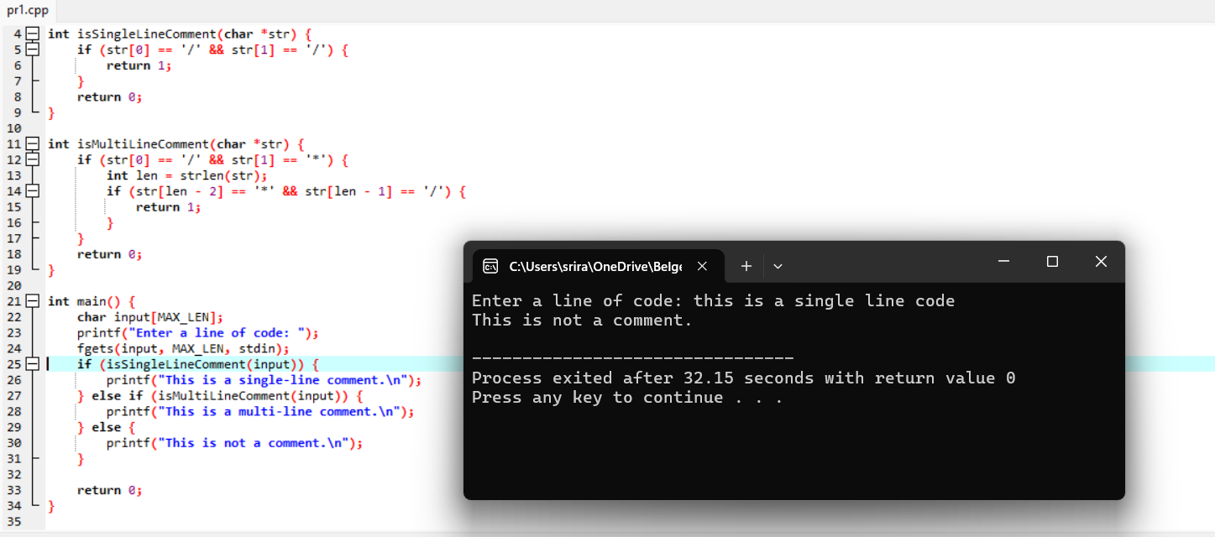

**PROGRAM 3**

**Design a lexical Analyzer for given language should ignore the redundant spaces, tabs and new lines and ignore comments using C**

**Aim**:  
To count the number of whitespace (spaces, tabs) and newline characters (\n) in a given input.

**Code:**

#include <stdio.h>

#include <ctype.h>

void skipWhitespaceAndComments(FILE *fp) {

char ch;

while ((ch = fgetc(fp)) != EOF) {

if (isspace(ch)) continue; // Skip spaces, tabs, and newlines

if (ch == '/' && fgetc(fp) == '/') { // Skip single-line comment

while ((ch = fgetc(fp)) != '\n' && ch != EOF);

}

else if (ch == '/' && fgetc(fp) == '*') { // Skip multi-line comment

while ((ch = fgetc(fp)) != '*' || fgetc(fp) != '/')

if (ch == EOF) break;

} else {

ungetc(ch, fp); // Valid character to process

break;

}

}

}

void handleIdentifier(FILE *fp) {

char token[100];

int index = 0;

char ch;

while (isalpha(ch = fgetc(fp)) || ch == '_') token[index++] = ch;

token[index] = '\0';

printf("Identifier: %s\n", token);

ungetc(ch, fp);

}

void handleConstant(FILE *fp) {

char token[100];

int index = 0;

char ch;

while (isdigit(ch = fgetc(fp))) token[index++] = ch;

token[index] = '\0';

printf("Constant: %s\n", token);

ungetc(ch, fp);

}

void handleOperator(char ch) {

printf("Operator: %c\n", ch);

}

void lexicalAnalyzer(FILE *fp) {

char ch;

while ((ch = fgetc(fp)) != EOF) {

if (isspace(ch)) continue;

if (isalpha(ch) || ch == '_') { ungetc(ch, fp); handleIdentifier(fp); }

else if (isdigit(ch)) { ungetc(ch, fp); handleConstant(fp); }

else if (ch == '+' || ch == '-' || ch == '*' || ch == '/') handleOperator(ch);

else printf("Unrecognized character: %c\n", ch);

skipWhitespaceAndComments(fp); // Skip spaces and comments before next token

}

}

int main() {

FILE *fp = fopen("source_code.txt", "r");

if (!fp) { printf("File not found!\n"); return 1; }

lexicalAnalyzer(fp);

fclose(fp);

return 0;

}

**Output:**

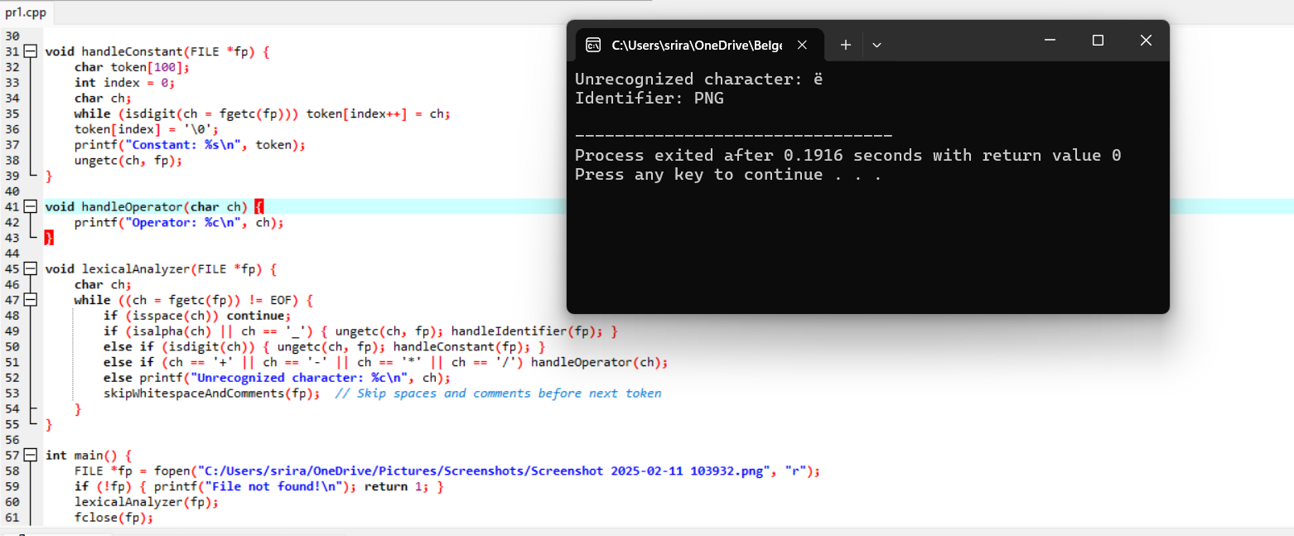

**PROGRAM 4**

**Design a lexical Analyzer to validate operators to recognize the operators +,-,*,/ using regular arithmetic operators using C**

**Aim:**

The aim of this program is to design a **lexical analyzer** in C that recognizes and validates the basic arithmetic operators: +, -, *, /. The program will read an input string, process it character by character, and print out the recognized arithmetic operators.

Code:

#include <stdio.h>

// Function to handle operators

void handleOperator(char ch) {

printf("Operator: %c\n", ch);

}

// Main function to perform lexical analysis

void lexicalAnalyzer(char *input) {

char ch;

int i = 0;

// Process each character in the input string

while ((ch = input[i]) != '\0') {

// Check for valid operators

if (ch == '+' || ch == '-' || ch == '*' || ch == '/') {

handleOperator(ch); // Print the operator if it's valid

}

i++; // Move to the next character

}

}

int main() {

char input[100];

// Get input from the user

printf("Enter an arithmetic expression: ");

fgets(input, sizeof(input), stdin);

printf("Lexical Analysis Result:\n");

lexicalAnalyzer(input); // Call the lexical analyzer function

return 0;

}

**Output:**

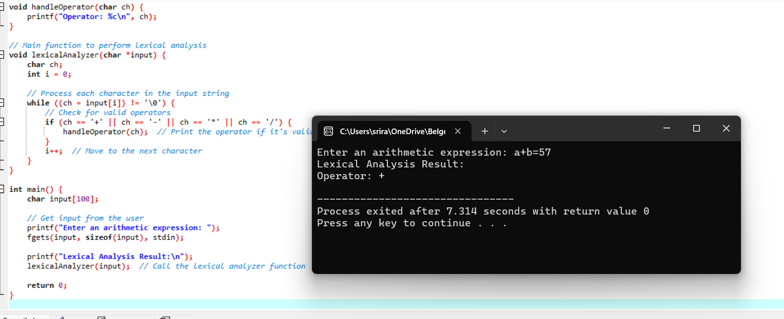

**PROGRAM 5**

**Design a lexical Analyzer to find the number of whitespaces and newline characters using C.**

**Aim:**

The aim of this program is to design a **lexical analyzer** in C that counts the number of whitespace characters (spaces and tabs) and newline characters (\n) in a given input string or file. This program will process the input character by character and keep track of the counts for whitespace and newline characters.

**Code:**

#include <stdio.h>

#include <ctype.h>

void countWhitespaceAndNewlines(FILE *fp) {

char ch;

int whitespaceCount = 0, newlineCount = 0;

// Read the file character by character

while ((ch = fgetc(fp)) != EOF) {

if (isspace(ch)) {

whitespaceCount++; // Increment for spaces and tabs

}

if (ch == '\n') {

newlineCount++; // Increment for newline characters

}

}

// Output the results

printf("Number of whitespace characters: %d\n", whitespaceCount);

printf("Number of newline characters: %d\n", newlineCount);

}

int main() {

FILE *fp = fopen("input.txt", "r"); // Open the file

if (fp == NULL) {

printf("Error opening file!\n");

return 1;

}

countWhitespaceAndNewlines(fp); // Call the function to count whitespaces and newlines

fclose(fp); // Close the file

return 0;

}

**Output:**

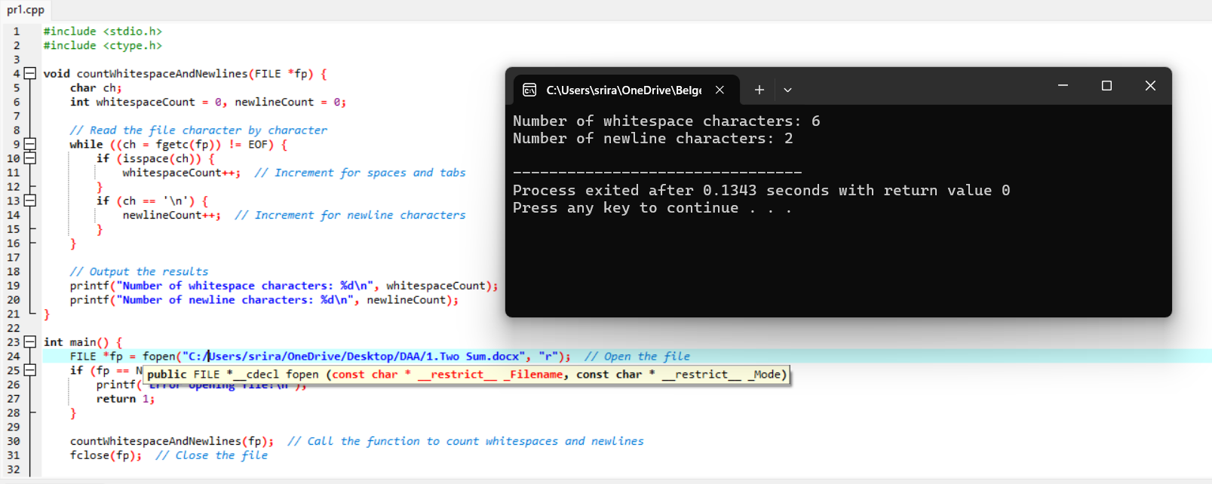

**PROGRAM 6  
Develop a lexical Analyzer to test whether a given identifier is valid or not using C.**

**Aim:**

To develop a lexical analyzer in C that checks whether a given identifier is valid according to the rules of the C programming language.

**Code:**

#include <stdio.h>

#include <ctype.h>

#include <string.h>

// List of C keywords

const char *keywords[] = {

"auto", "break", "case", "char", "const", "continue", "default", "do", "double",

"else", "enum", "extern", "float", "for", "goto", "if", "inline", "int", "long",

"register", "restrict", "return", "short", "signed", "sizeof", "static", "struct",

"switch", "typedef", "union", "unsigned", "void", "volatile", "while", "_Alignas",

"_Alignof", "_Atomic", "_Bool", "_Complex", "_Generic", "_Imaginary", "_Noreturn",

"_Static_assert", "_Thread_local"

};

// Function to check if a given string is a keyword

int isKeyword(char *str) {

int n = sizeof(keywords) / sizeof(keywords[0]);

for (int i = 0; i < n; i++) {

if (strcmp(str, keywords[i]) == 0)

return 1; // It is a keyword

}

return 0;

}

// Function to check if a given string is a valid identifier

int isValidIdentifier(char *str) {

// Check if it's a keyword

if (isKeyword(str))

return 0;

// Check if the first character is a letter or underscore

if (!isalpha(str[0]) && str[0] != '_')

return 0;

// Check remaining characters

for (int i = 1; str[i] != '\0'; i++) {

if (!isalnum(str[i]) && str[i] != '_')

return 0;

}

return 1;

}

int main() {

char identifier[50];

printf("Enter an identifier: ");

scanf("%s", identifier);

if (isValidIdentifier(identifier))

printf("\"%s\" is a valid identifier.\n", identifier);

else

printf("\"%s\" is not a valid identifier.\n", identifier);

return 0; }

**Output:**

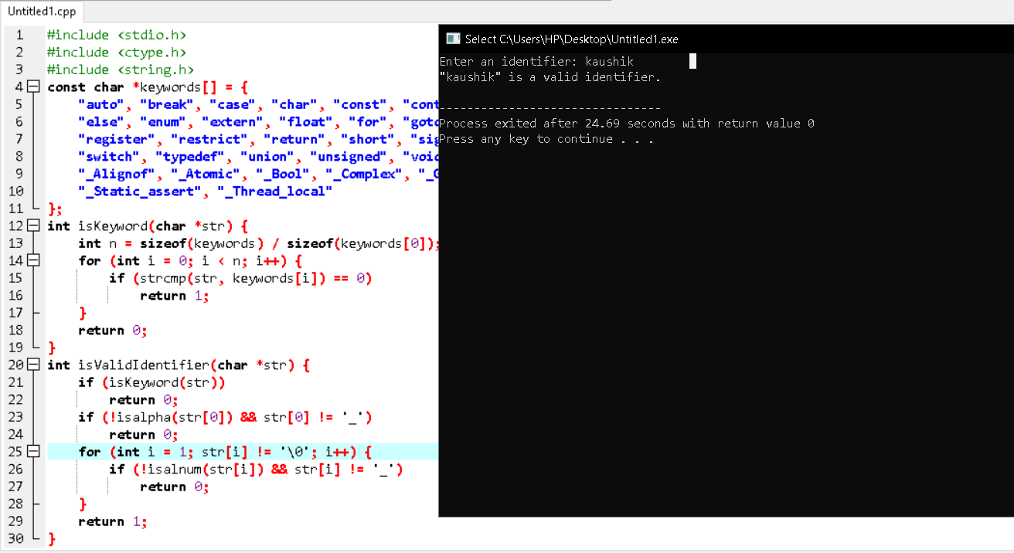

**PROGRAM 7**

**Aim:**

To implement a C program that computes the **FIRST()** sets for a given context-free grammar (CFG) as part of a predictive parser.

**Code:**

#include <stdio.h>

#include <string.h>

#include <ctype.h>

#define MAX 10

int isTerminal(char c) {

return !isupper(c);

}

void findFirst(char grammar[MAX][MAX], int n, char nonTerminal, char first[MAX]) {

for (int i = 0; i < n; i++) {

if (grammar[i][0] == nonTerminal) {

if (isTerminal(grammar[i][2])) {

first[strlen(first)] = grammar[i][2];

} else {

first[strlen(first)] = grammar[i][2];

}

}

}

}

int main() {

int n;

char grammar[MAX][MAX], first[MAX];

printf("Enter number of productions: ");

scanf("%d", &n);

getchar();

printf("Enter the productions (in the form: A->a or A->B):\n");

for (int i = 0; i < n; i++) {

fgets(grammar[i], MAX, stdin);

grammar[i][strcspn(grammar[i], "\n")] = 0;

}

for (int i = 0; i < n; i++) {

char nonTerminal = grammar[i][0

printf("FIRST(%c) = {", nonTerminal);

memset(first, 0, sizeof(first));

findFirst(grammar, n, nonTerminal, first);

for (int j = 0; first[j] != '\0'; j++) {

printf("%c ", first[j]);

}

printf("}\n");

}

return 0;

}

**Output:**

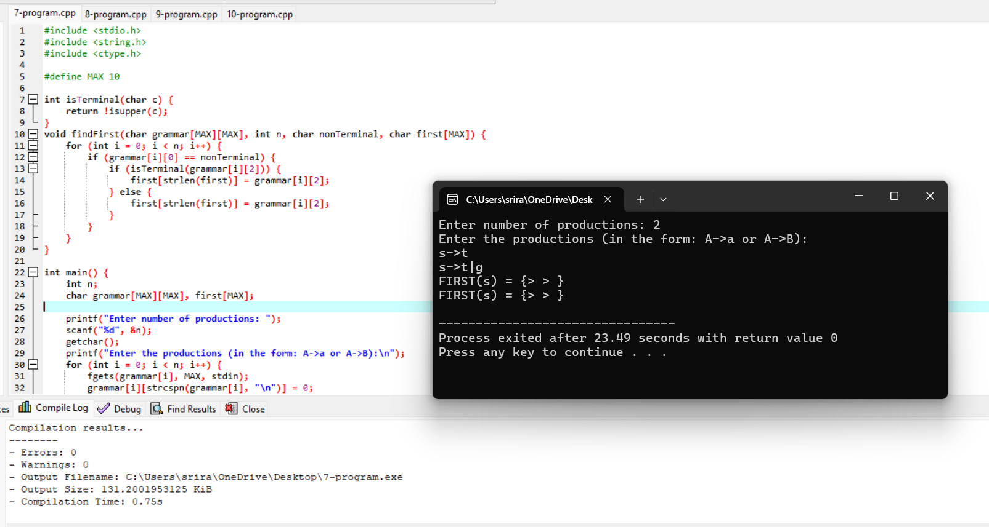

**PROGRAM 8**

**Aim:**

To implement a C program that computes the **FOLLOW()** sets for a given context-free grammar (CFG) as part of a predictive parser. The **FOLLOW()** sets indicate which terminals can appear immediately to the right of a non-terminal in some sentential form.

**Code:**

#include <stdio.h>

#include <string.h>

#include <ctype.h>

#define MAX 10

#define ALPHABET_SIZE 26

int isTerminal(char c) {

return !isupper(c);

}

int isNonTerminal(char c) {

return isupper(c);

}

void findFollow(char grammar[MAX][MAX], int n, char nonTerminal, char follow[MAX]) {

int changed = 1;

while (changed) {

changed = 0;

for (int i = 0; i < n; i++) {

for (int j = 2; grammar[i][j] != '\0'; j++) {

if (grammar[i][j] == nonTerminal) {

if (isTerminal(grammar[i][j + 1])) {

follow[strlen(follow)] = grammar[i][j + 1];

changed = 1;

} else if (isNonTerminal(grammar[i][j + 1])) {

follow[strlen(follow)] = grammar[i][j + 1];

changed = 1;

} else if (grammar[i][j + 1] == '\0') {

follow[strlen(follow)] = grammar[i][0]; // Left-hand side non-terminal

changed = 1;

}

}

}

}

}

}

int main() {

int n;

char grammar[MAX][MAX], follow[MAX];

char nonTerminals[MAX] = "SAB";

printf("Enter number of productions: ");

scanf("%d", &n);

getchar();

printf("Enter the productions (in the form: A->a or A->B):\n");

for (int i = 0; i < n; i++) {

fgets(grammar[i], MAX, stdin);

grammar[i][strcspn(grammar[i], "\n")] = 0

}

for (int i = 0; i < MAX; i++) {

follow[i] = '\0'; // Clear FOLLOW sets

}

follow[0] = '$';

for (int i = 0; i < strlen(nonTerminals); i++) {

char nonTerminal = nonTerminals[i];

printf("FOLLOW(%c) = {", nonTerminal);

memset(follow, 0, sizeof(follow)); // Clear the FOLLOW set

findFollow(grammar, n, nonTerminal, follow);

for (int j = 0; follow[j] != '\0'; j++) {

printf("%c ", follow[j]);

}

printf("}\n");

}

return 0;

}

**Output:**

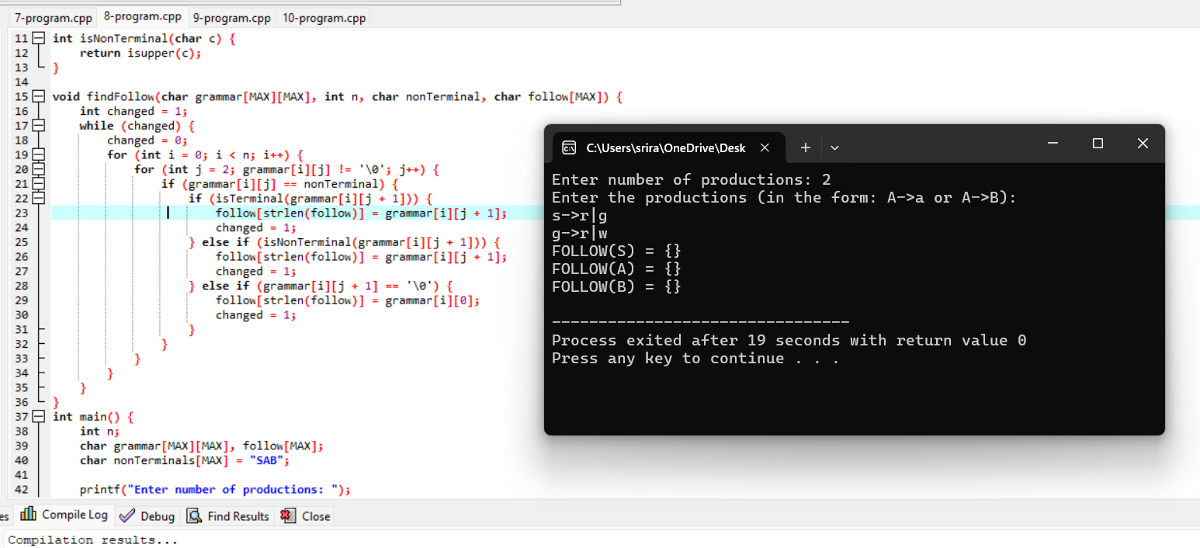

**PROGRAM 9**

**Aim:**

To implement a C program that eliminates left recursion from a given context-free grammar (CFG). Left recursion occurs when a non-terminal on the left-hand side of a production rule appears at the beginning of its own right-hand side, leading to infinite recursion in recursive descent parsers.

**Code:**

#include <stdio.h>

#include <string.h>

#include <ctype.h>

#define MAX 10

int isTerminal(char c) {

return !isupper(c);

}

void eliminateLeftRecursion(char grammar[MAX][MAX], int *n, char nonTerminal) {

char newNonTerminal = nonTerminal + '1'

char newGrammar[MAX][MAX];

int newProductionCount = 0;

int i = 0, j = 0;

for (i = 0; i < *n; i++) {

if (grammar[i][0] == nonTerminal) {

if (isTerminal(grammar[i][2])) {

sprintf(newGrammar[newProductionCount++], "%c→%s%c", nonTerminal, grammar[i] + 2, newNonTerminal);

}

} else {

sprintf(newGrammar[newProductionCount++], "%s", grammar[i]);

}

}

sprintf(newGrammar[newProductionCount++], "%c→ε", newNonTerminal);

for (i = 0; i < newProductionCount; i++) {

printf("%s\n", newGrammar[i]);

}

}

int main() {

int n;

char grammar[MAX][MAX];

printf("Enter number of productions: ");

scanf("%d", &n);

getchar();

printf("Enter the productions (in the form: A->a or A->B):\n");

for (int i = 0; i < n; i++) {

fgets(grammar[i], MAX, stdin);

grammar[i][strcspn(grammar[i], "\n")] = 0;

}

printf("\nOriginal Grammar:\n");

for (int i = 0; i < n; i++) {

printf("%s\n", grammar[i]);

}

for (int i = 0; i < n; i++) {

if (isupper(grammar[i][0])) {

printf("\nAfter Eliminating Left Recursion for Non-Terminal %c:\n", grammar[i][0]);

eliminateLeftRecursion(grammar, &n, grammar[i][0]);

}

}

return 0;

}

**Output:**

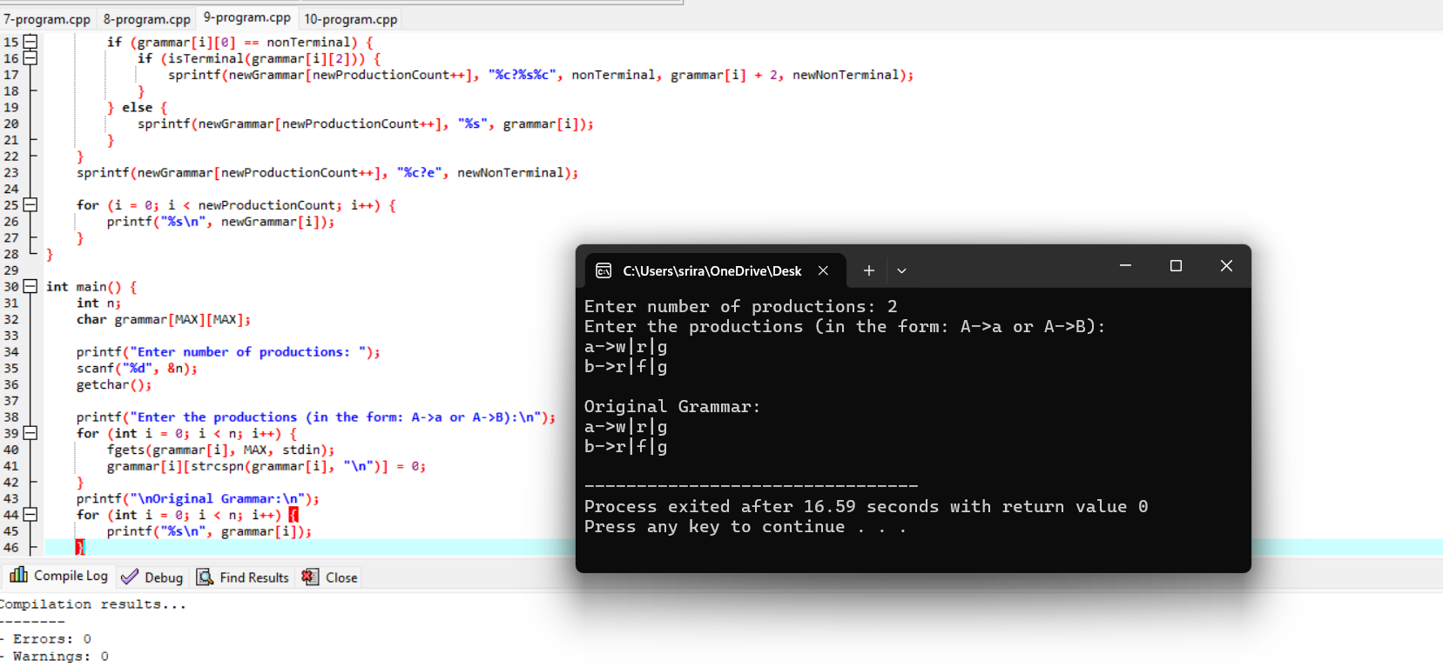

**PROGRAM 10**

**Aim:**

To implement a C program that eliminates **left factoring** from a given context-free grammar (CFG). Left factoring is a technique used to transform grammars that have common prefixes into a form where the choice between alternatives is made after the common prefix is processed.

**Code:**

#include <stdio.h>

#include <string.h>

#define MAX 10

#define MAX_PROD 100

int isTerminal(char c) {

return !(c >= 'A' && c <= 'Z');

}

void eliminateLeftFactoring(char grammar[MAX_PROD][MAX], int *n) {

char newGrammar[MAX_PROD][MAX];

int newProductionCount = 0;

for (int i = 0; i < *n; i++) {

for (int j = i + 1; j < *n; j++) {

if (grammar[i][0] == grammar[j][0] && grammar[i][2] == grammar[j][2]) {

char prefix[MAX] = {0};

int k = 2;

while (grammar[i][k] == grammar[j][k] && grammar[i][k] != '\0') {

prefix[k - 2] = grammar[i][k];

k++;

}

char newNonTerminal = grammar[i][0] + 1;

sprintf(newGrammar[newProductionCount++], "%c→%s", newNonTerminal, prefix);

sprintf(newGrammar[newProductionCount++], "%c→%s%c", grammar[i][0], prefix, newNonTerminal);

sprintf(newGrammar[newProductionCount++], "%c→%s", newNonTerminal, grammar[i] + k);

grammar[i][0] = '\0';

grammar[j][0] = '\0';

}

}

}

printf("\nGrammar after Left Factoring:\n");

for (int i = 0; i < newProductionCount; i++) {

printf("%s\n", newGrammar[i]);

}

}

int main() {

int n;

char grammar[MAX_PROD][MAX];

printf("Enter the number of productions: ");

scanf("%d", &n);

getchar();

printf("Enter the productions in the form A->alpha:\n");

for (int i = 0; i < n; i++) {

fgets(grammar[i], MAX, stdin);

grammar[i][strcspn(grammar[i], "\n")] = 0;

}

printf("\nOriginal Grammar:\n");

for (int i = 0; i < n; i++) {

printf("%s\n", grammar[i]);

}

eliminateLeftFactoring(grammar, &n);

return 0;

}

**Output:**

